How to Extend View in Oracle EBS R12
  - Identify the view that you want to extend:
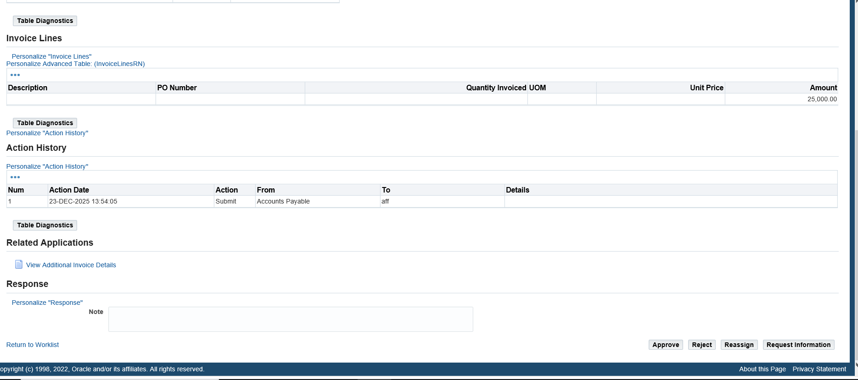
- Go to “About this page”
- Expand All, and find the View you want to extend.
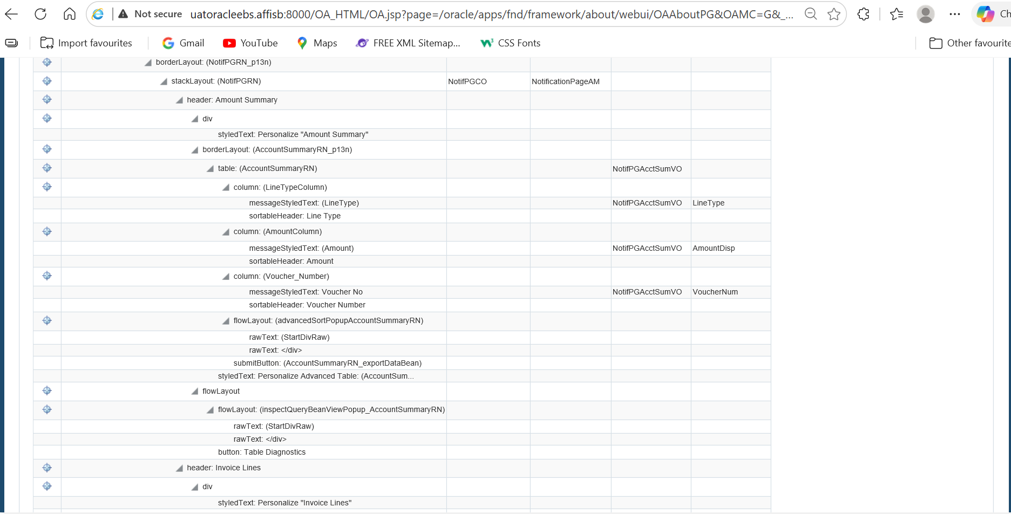
- So, after identifying, click on Vo (NotiPGAcctSumVO)
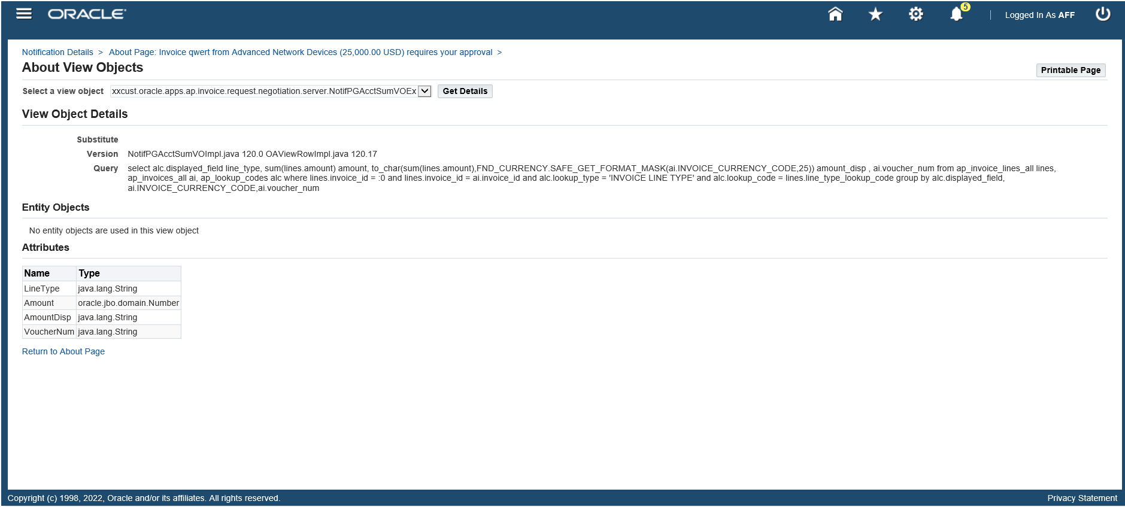
- So, you identify which view has the query you want to extend

  - Download the Files from Server:
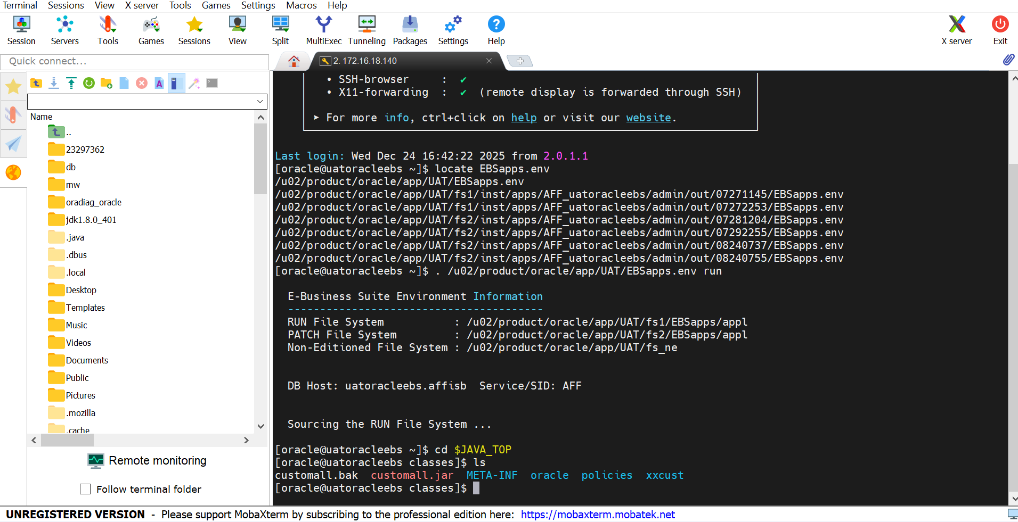
- Go to Java_Top directory
- The above screenshot has the path of the file (VO) you want to extend
- /u02/product/oracle/app/UAT/fs1/EBSapps/comn/java/classes/oracle/apps/ap/invoice/request/negotiation/server (complete path for Voucher number VO) (NotifPGAcctSumVO)

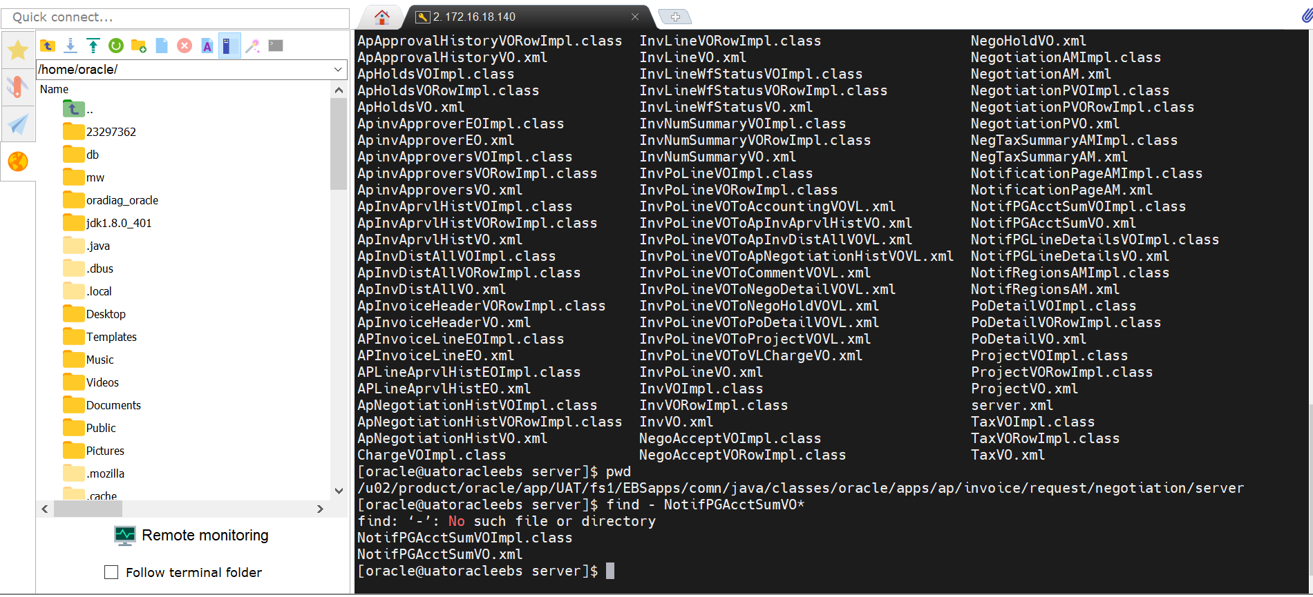
- Above Screenshot to find the relevant Files.

  - Folder Creation on your local machine:
- First of all, create a folder in “C:\jdeveloper12.2.12\jdevhome\jdev\myprojects”
- Use the same hierarchy of folders that you have on your server.
- Get NotifPGAcctSumVO.class and NotifPGAcctSumVOIMPL.class from server ($JAVA_TOP) download them under the same path in jdeveloper(in our example: oracle/apps/ap/invoice/request/negotiation/server/).

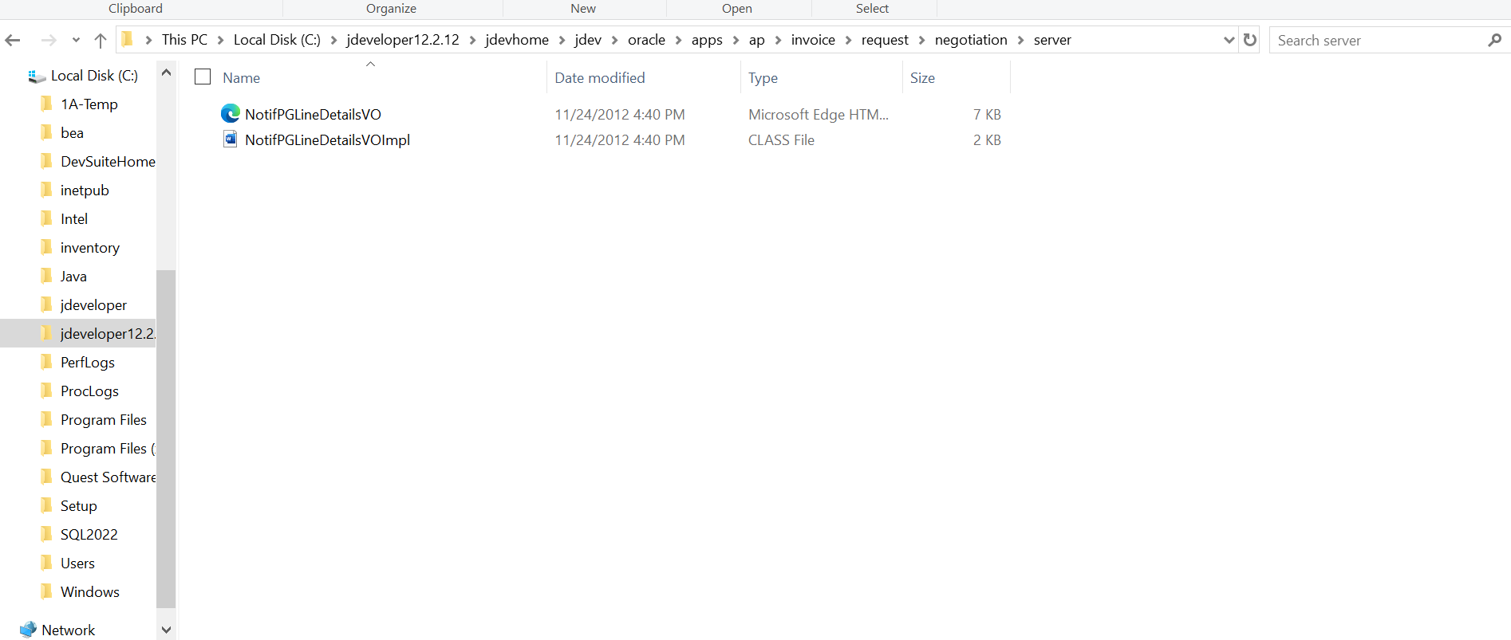

  - Create a new project on JDeveloper:
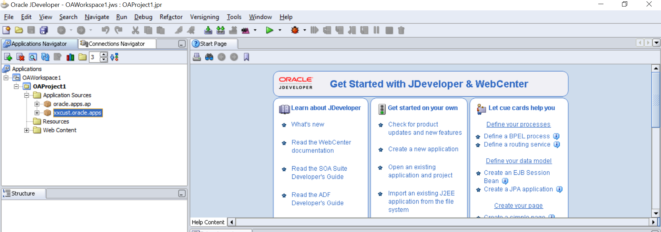
- Add New project
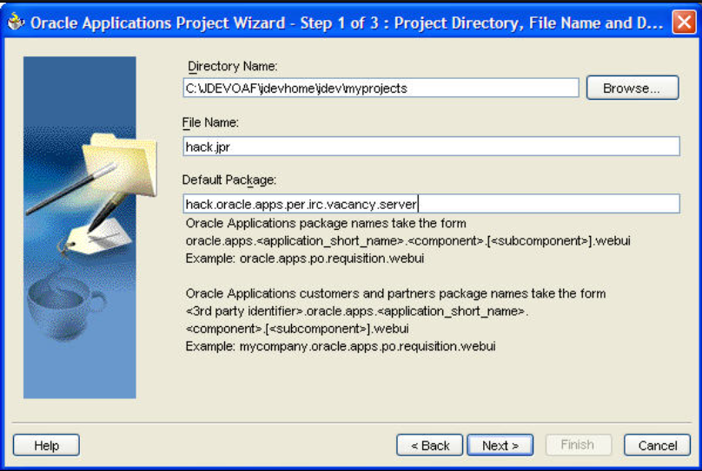
- In the default package use: oracle.apps.ap.invoice.request.negotiation.server
- Because you create that hierarchy folder on your local machine
- Connect to the database.
  - Add ADF Business Component:
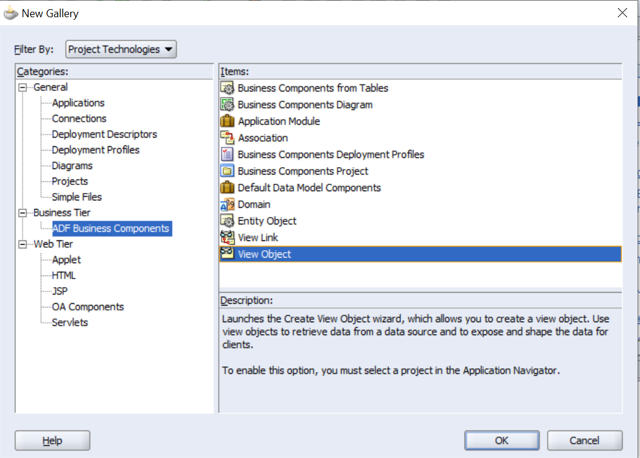

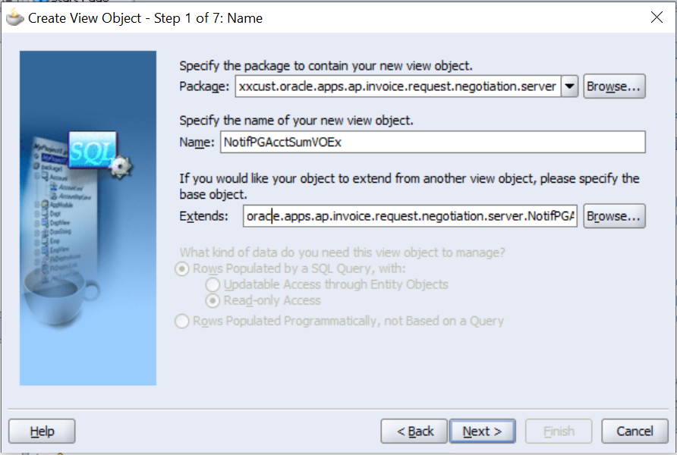
- Update the query:
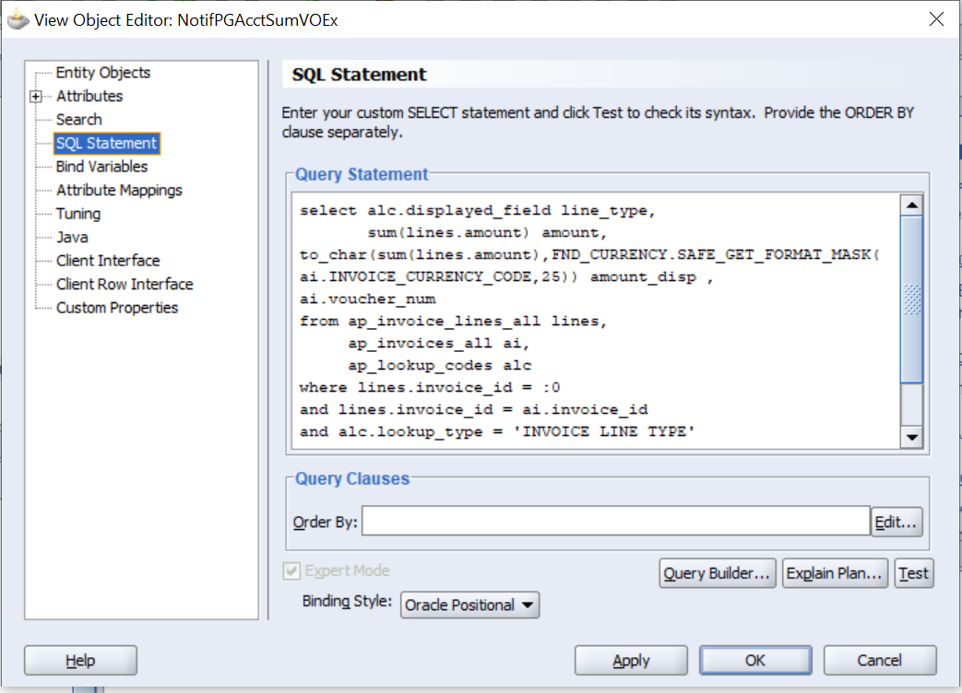
- Test your query.
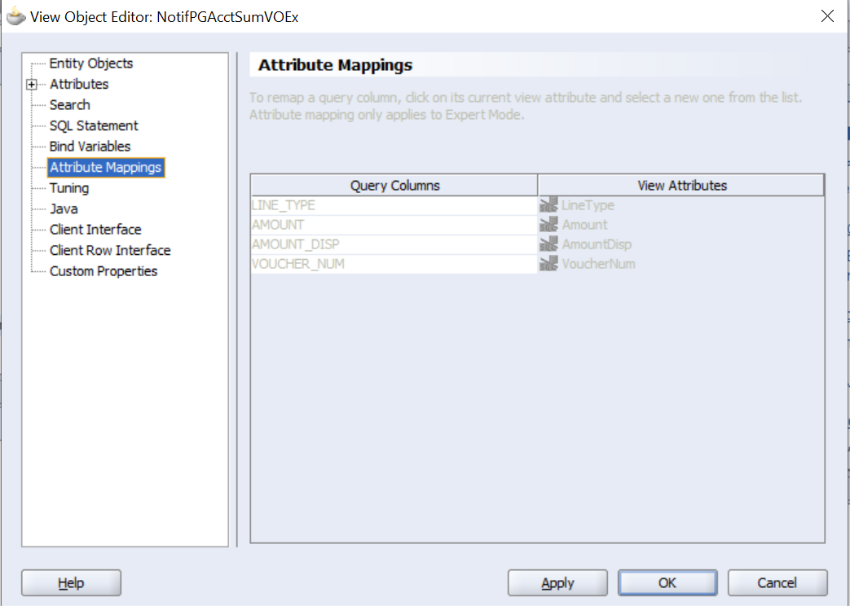

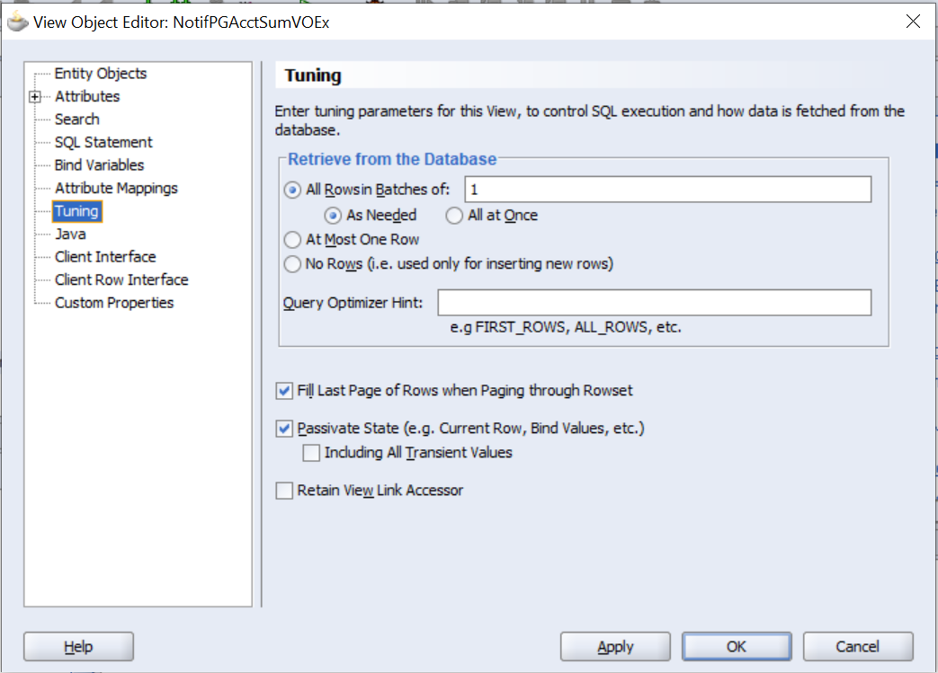
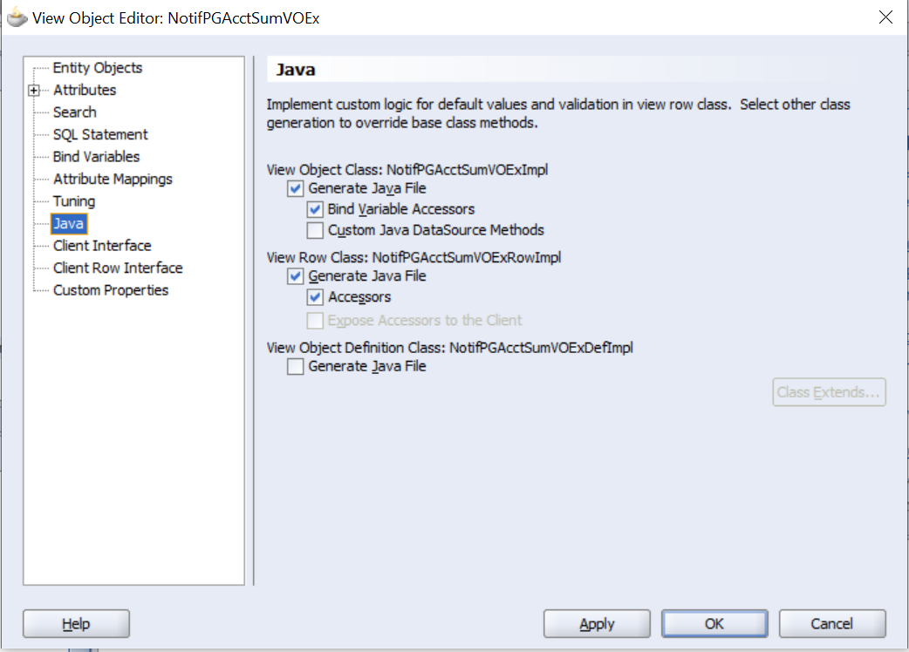
- Generate JAva File
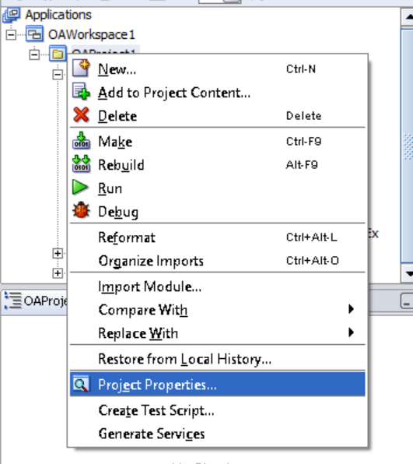
- Go to project properties to substitute the files.
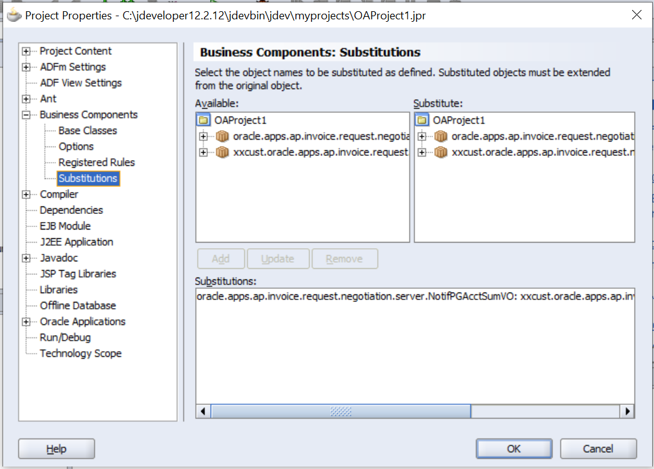
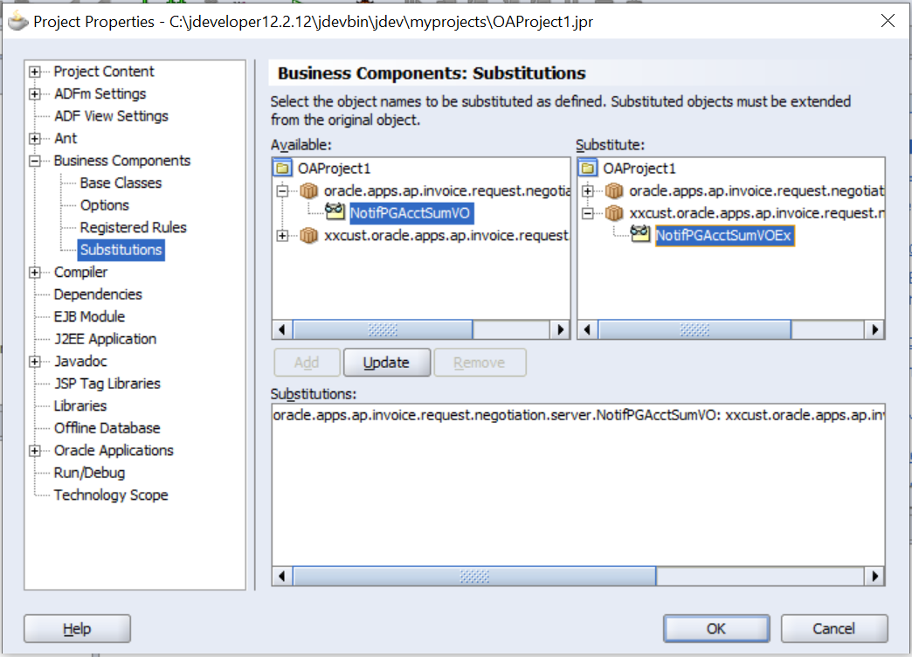
- Add to substitute extended view with standard view
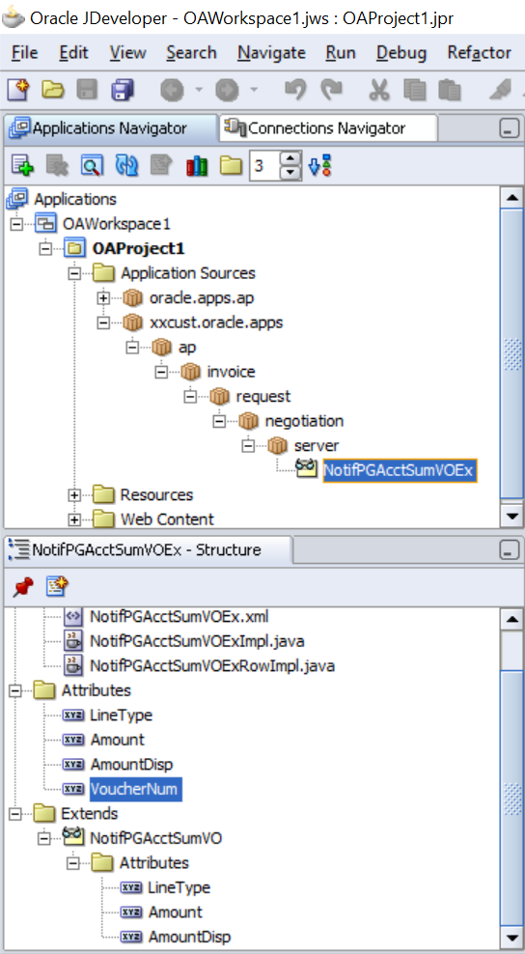
- Above, you can see the complete details that you create your view
- Save your project by clicking on the Save Button
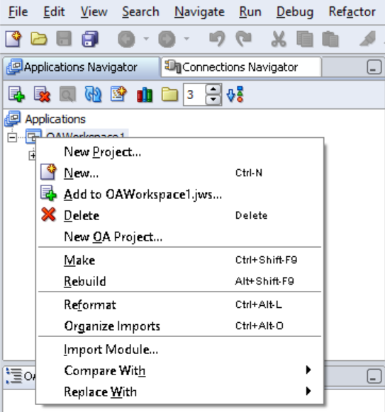
- Click on Make if no error, then click on Rebuild
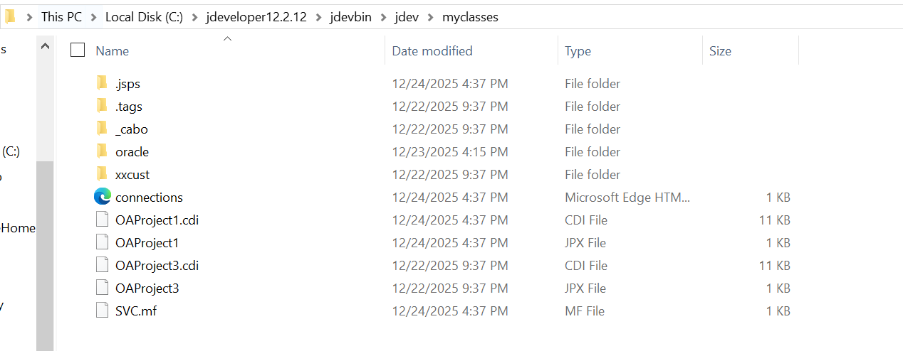
- Go to myclasses folder on local machines and check xxcust and OAProject.JPX file created(Note: Must see time for latest or updated files)
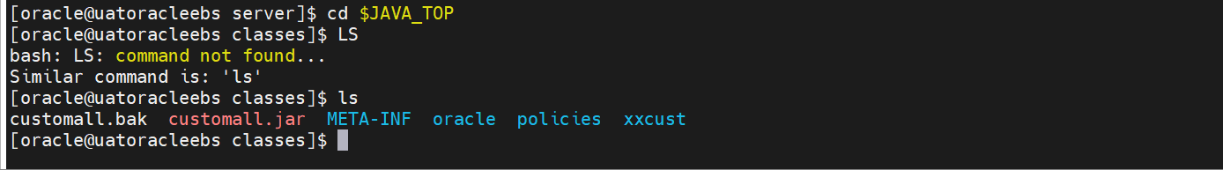
- Go to JAVA_TOP folder, paste the xxcust folder
- In the xxcust folder, paste OAProject1.JPX file
- java oracle.jrad.tools.xml.importer.JPXImporter /u02/product/oracle/app/UAT/fs1/EBSapps/comn/java/classes/xxcust/OAProject1.jpx -username apps -password apps -dbconnection "(DESCRIPTION=(ADDRESS=(PROTOCOL=tcp)(HOST=172.16.18.140)(PORT=1521))(CONNECT_DATA=(SID=AFF)))"
Run the above command on the xxcust folder for “import documents files.”

- Go to $AD_TOP/bin Run adcgnjar command. Just enter adcgnjar and then enter
Provide the DB apps password.

- Then go to $ADMIN_SCRIPTS_HOME and bounce OA core on Weblogic
sh admanagedsrvctl.sh stop oacore_server1
sh admanagedsrvctl.sh start oacore_server1

- Go to ebs, log in, and check if the page has an error, then solve that issue if the page does not contain errors.
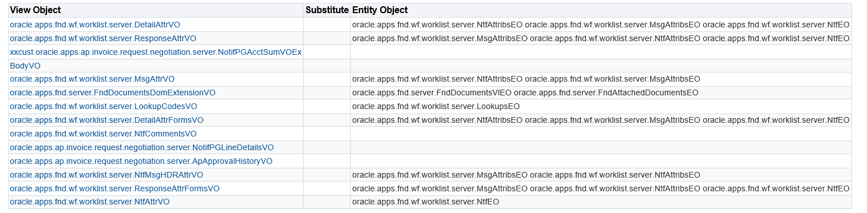
  - Personalization on the front end for showing data:
Reference:
- https://bbargapps.blogspot.com/2017/04/oracle-ebs-r1226-extending-view-object.html
- https://oracleapps88.blogspot.com/2011/08/how-to-extend-view-object-in-oaf.html
- https://yesyespatil.blogspot.com/p/vo-ext.html

- FTP each .tar file to \jdevhome\jdev\myclasses.
- Extract each .tar file in the \jdevhome\jdev\myclasses directory
- Also extract each .tar file in the \jdevhome\jdev\myprojects directory.
Issue:
oracle.apps.fnd.framework.OAException: oracle.jbo.SQLStmtException: JBO-27122: SQL error during statement preparation.
java.sql.SQLException: Attempt to set a parameter name that does not occur in the SQL: VouchNum
